**Player Count:** 4 players

**Player Ages:** 12+

**Playing Time:** 30 - 45 minutes

**Categories:** story-telling, serious game

The Neighbourhood is a thrilling game where players tell unique and fun stories to each other while facing imminent challenges and opportunities in the cities. Will the players be able to create a better city or will the city fall into waste?

**Learning Goals**

* Shared experiences with the other players - get to know each other better
* Knowledge on the opportunities and events in a city
* Cooperation between neighbours is important to solve certain challenges

**Objective in the Game**

* Prevent the city categories reaching -5 or lower, otherwise everyone loses the game.
* Get a high personal score in the 4 - 8 rounds played
  + Improvements to the city
  + Points in your own personal city category

**Requirements**

* Game map: city categories with points
  + Put items on the map to showcase how well a category scores (pawns)
* Cards:
  + Opportunity cards
  + Event cards
  + Neighbour cards
  + Story Opening cards
  + Action cards
  + Category cards
* Mini-neighbours: >24 mini-neighbours (discs)
* Personal points: keep track of the personal scores of every player (coins, fiches, notepad)
* Timer: stories should be between 30-60 seconds

**Rules**

* Give applause for the stories
* Be respectful during the storytelling

**Gameplay**

* All players choose a personal category based on which category they find most important. The chosen category remains hidden until the end of the game.
* All players receive an action card, a category card, an opportunity card and a neighbour disc.
* Follow the steps on the action card iteratively:

**Event happens**: Draw an event card and adjust the neighbourhood categories

**Storytelling**: Draw a neighbour card and a story opening card: a starting point for the stories. (youngest player starts in round 1, then shift turns clockwise) Recap on the stories after all stories have been shared.

**Voting:** Players vote on the best story and every vote rewards a neighbour disc.

**Winner gets opportunity card:** Reward an opportunity to the player that received the most votes. In case of a draw, the player that told their story earlier receives the card.

**Improve Neighbourhood:** Players get the chance to spend 1 neighbour disc to improve 1 category by 1 or 4 discs can be used to perform an opportunity, which rewards 7 points in total.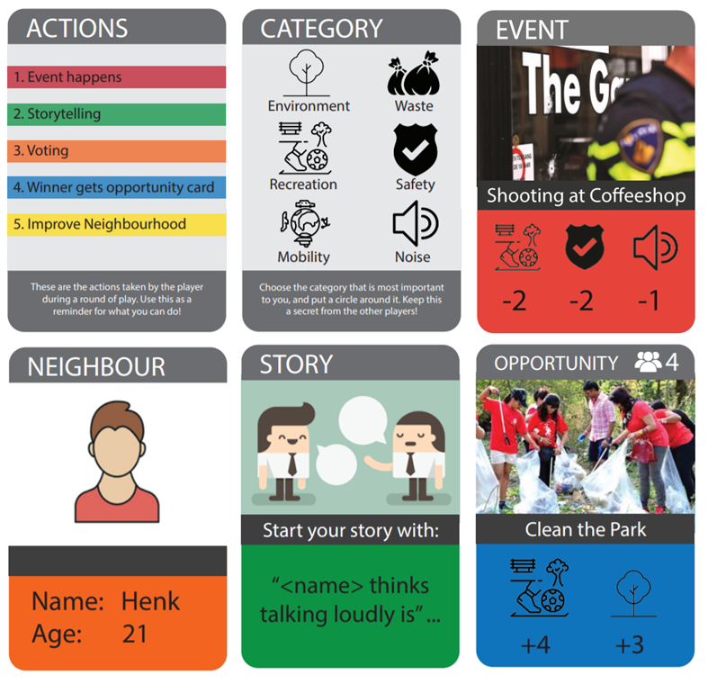

# 

# Facilitation flow

***As facilitator, you are meant to read the sentences below out loud. Only the sentences written in italic are actions the facilitator should do, and not read out loud.***

Welcome to the neighbourhood everyone. My name is “***say your name***” and I am a representative of the municipality. Today we are going to try to improve our neighbourhood together, by focussing on six categories: Waste, Recreation, Noise, Mobility, Environment and Safety. These are the aspects of your neighbourhood of which the municipality thinks you and your neighbours can improve. The current state of each aspect is shown using the meters **show game board.** If a score drops to -5, the city can no longer handle the problems and the game ends. Otherwise, we will play 4 to 8 rounds.

Think of your city and the aspects shown on your card. Which one is the most important to you? Choose one of these six categories privately, and circle this category down on your “category paper” ***hand over the category papers***

As the game is about working together to improve the city, you will need neighbours to help each other. You will receive one of these mini-neighbours, which represents yourself. ***Hand over one mini-neighbour per player***

Also, I would like to inform you that the municipality has found some opportunities for improvement which we would like to share with you. ***Hand over one random opportunity card per player***

These opportunities and neighbours will help you to make the neighbourhood a better place, and can also earn you points. 1 individual neighbour can be traded in to increase a category of choice by 1. This will award 1 individual point as well. An opportunity has a cost of 4 neighbours, but will award 7 points, as they increase the neighbourhood categories by 7 altogether.

Sometimes negative events take place in the neighbourhood that decrease the livability. Every round of play will start with one of these “events”, lowering the scores on the board. ***Draw random event card and read it out loud. Then adjust the categories according to the event card.***

It is now time for meeting one of your neighbours and their story. You will each tell a story about this neighbour using the story opening card as a starting sentence for your story. It’s important that this story is liked by the other players, as after the storytelling, you will all vote on the best story.

For every vote that your story receives, you will be awarded an additional neighbour that can be used to improve the neighbourhood. Also, the story that receives the most votes will be awarded an additional random opportunity card. In case of a draw, this card will be awarded to the player whose turn was earlier.

To decide the order for the first round, the youngest player begins. Who is the youngest player? Next round, the player on their left will start.

***Draw a random neighbour card and a random story opening card and give them to the starting player of the round.***

You have got no more than 60 seconds to come up with a story and tell this story, after a story we clap to appreciate the sharing then the next player tells a story. ***Prepare to start timer and wait until player seems ready. Say “you can start” if the player hesitates.***

***NOTE TO FACILITATOR: PREVENT THAT PLAYERS (AND YOU) REACT TO OTHER’S STORIES, ONLY ALLOW THIS IN THE RECAP.***

***Wait until the player has finished their story and start applauding. If the other players do not also start applauding say:*** *It is important that we show appreciation for the stories.*

Thank you all for introducing this neighbour. Before we decide on the best story, please give a short recap of your stories so that every player is on the same page… ***Wait for the players to tell the recaps…***

It is now time to decide upon the best story. All players put your finger in the air, and on the count of 3, you point at the player whose story you liked the most. You can’t vote for your own story.

Hold your fingers a little longer, while I award the mini-neighbours. ***Give the additional neighbours proportional to the number of votes that a player received.***

***Give the player that received the most votes an opportunity card (in case of a draw explain again that the player whose turn was earlier receives the card as they had less thinking time and story input).***

To improve the neighbourhood, either play 1 mini-neighbour for 1 point improvement OR play an opportunity card, costing 4 neighbours. Think of your secret goal and keep in mind that any time the city reaches a -5, the game is lost.

***Give some time and space for the players to think, interact and chose to act or not.***

***If players decide to act, change the categories in the right way, and award individual points. Also take the neighbours that were used from the players.***

From this point on, the game will continue in a similar fashion. I am here to help guide you through it if necessary. **Play next round, just as above. If questions arise try to answer them as facilitator.**

**NOTE TO FACILITATOR: CONTINUE ROUNDS UNTIL EITHER -5 IS REACHED OR THE OVERALL MOTIVATION TO SHARE STORIES IS DECLINE (AFTER AROUND 4-6 ROUNDS).**

## Debrief

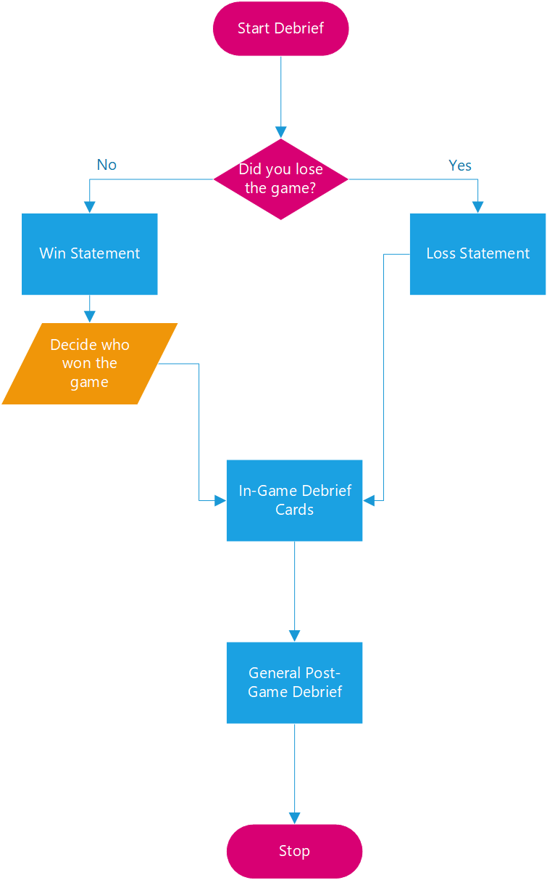

**Loss Statement [READ HERE IF RATING WENT TO -5]**

As you can see, the neighbourhood has some major problems with <aspect>. This means you have unfortunately lost the game. (Tell some more about what these problems would mean, make up a story).

What do you think went wrong? What could you improve next time?

*Focus on the role of collaboration in preventing this outcome.*

**Win Statement [READ HERE IF GAME ENDS WITHOUT FAILURE]**

Great job! You made the neighbour a much nicer place. Because of your interventions, the neighbourhood has improved a lot in <aspects>. (Make up a story of how the neighbourhood looks better with these improved aspects).

Why did you think you were able to get such a positive result?

*Focus on the role of collaboration in strengthening this outcome.*

How many points did everyone get? Who has won?

**In-Game Debrief Cards**

***Give each player one free opportunity, event, and neighbour card + three storytelling cards***

Opportunity card: make the player come up with an idea on how to improve their neighbourhood themselves

Event card: which event they find important in their neighbourhood

Neighbour card:

* Name and age
* What they find important in the neighbourhood
* What they can do to improve the neighbourhood

**General Post-Game Debrief**

First discussion in groups, then a plenary discussion on the most important points

* What did you like about the game?
* What did you dislike about the game?
* Do you participate in the neighbourhood in real life?
  + What forms a barrier to talk with each other?
* Did these stories make you feel more connected to the other players?
* Could you relate to the game?